About
The Company
Sithembe Transportation and Projects (Pty) Ltd is a reputable organization that prioritizes honesty and the employment of qualified professionals in the fields of Built Environment, Civil Engineering, Electrical Engineering, Horticultural services, and Road Marking. They have successfully completed projects in Mpumalanga, Limpopo, Gauteng, North-West, and Kwa-Zulu Natal provinces, with plans for further expansion nationwide.
The company's primary goal is to bring innovation to the Built Environment, Civil Engineering, Electrical Engineering, Horticultural services, and Road Marking industries, particularly through the implementation of advanced digital reporting software and other technological solutions.
Sithembe Transportation and Projects (Pty) Ltd is duly registered with the relevant regulatory bodies in South Africa and has plans to register with additional Technology and Engineering organizations.

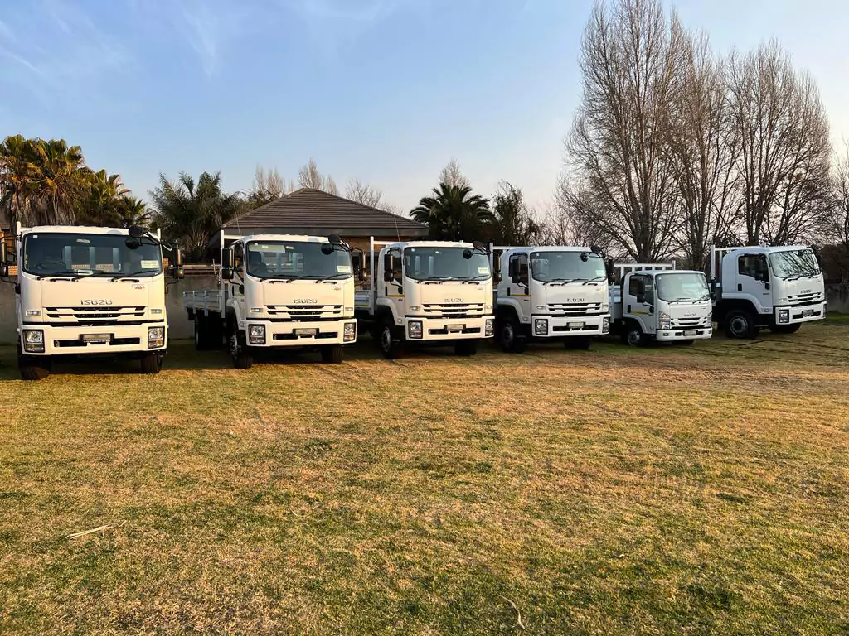
OUR GOAL
STP is committed to fostering inclusivity and empowerment by prioritizing the employment of women and youth, particularly those from disadvantaged backgrounds. The company also aims to provide opportunities for young graduates to enter and gain valuable experience in the Built Environment and Civil Engineering sector. Their ultimate goal is to disrupt the stagnant economic status quo in the industry, not only by creating jobs but also by establishing a platform for mutual growth and transformation.
OUR CORE VALUES

Innovative
We are committed to innovation and creative solutions.

Ethics And Integrity
We conduct our business with honesty and integrity.

Excellent Service
We strive to exceed our clients' expectations.

WE AIM TO CONTRIBUTE AND EMPOWER TO OUR COMMUNITIES
Our organization is committed to creating a positive impact in our communities by empowering individuals to achieve their fullest potential. Through our various projects, we strive to provide resources and support to those in need, whether it be through education, healthcare, or other essential services. We believe that by working together, we can make a significant difference in the lives of those around us and create a brighter future for all. Join us in our mission to empower and uplift our communities.
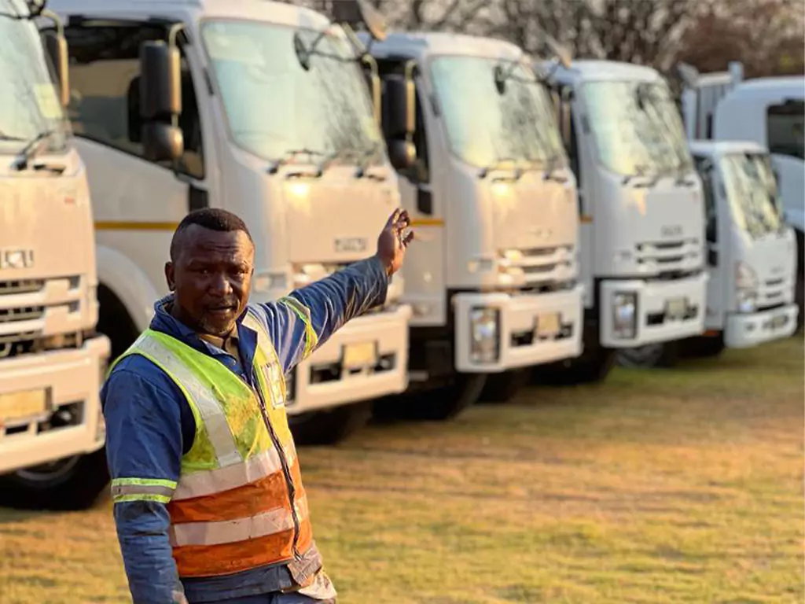
OUR STAFF
Our company has a technical sales and management structure which ensures administrative accountability, transparency and exceptional client service. Continual in-service training is provided by outside specialists to all technical sales and management staff. Administrative and technical control is exceptionally important to us, and we therefore ensure that all our staff are technically qualified and upholds professionalism to the highest level. The company is structured in such a way that minimizes overheads as much as possible.


SERVICES WE PROVIDE
LANDSCAPING| 6SH

ELECTRICAL ENGINEERING| 6EP

Work suits & Helmets
Safety Shoes
Mops, Mutton cloth, Brooms
Knapsack Sprayers
Gumboots (Neptune, Wayne)
CIVIL ENGINEERING | 6CE

CLEANING SERVICES

LANDSCAPING

GENERAL BUILDING| 5GB

ROAD MARKINGS| 4SK

PLANT HIRE

SUPPLY AND DELIVERY

OUR ASSETS
2 x Cherry Picker Truck
5 x 10 000l Water Tanks
3 x Tractors
6 x Ride on Machines
60 x Brush Cutters
4 x Walk behind Cutters
30 x Chainsaws
5 x Rollers
10 x 8 Ton Trucks
6 x 15 000l Honey Sukers

4 x H-100 Bakkies

6 x LDV Bakkies
2 x TLB Back Loader
2 x Excavator
4 x Tipper Trucks
5 x Lowbed Trucks

6 x Bissell Sport Clean – Hydro Steam Wet & Dry Deep Cleaner
4 x Laser Master Versatile


10 x Carpet Hoovers
30 x Mops & Buckets



10 x Vacuum Cleaners
30 x Brooms

10 x Heavy-Duty Degreaser
8 x Stump Grinding Machines

OUR WORKING EXPERIENCE
Client / Organisation | Category | Description | Period
City of Tshwane | Civil Engineering | Tender for the corporative hire of general construction vehicles and refuse removal vehicles, as and when required. | 3 years from 13 August 2021
City of Tshwane | Landscaping | Grass cutting and tree maintenance services. | Ongoing
City of Tshwane | Civil Engineering | Tender for the general repairs of City of Tshwane's light vehicles. | 3 years from 1 June 2022
City of Tshwane | Plant Hire | Tender for hire of 10 000l mobile drinking water tankers for supply in informal settlements. | 3 years from 14 May 2022
City of Tshwane | Cleaning Services | Appointment of service providers for removal, cleaning and rehabilitation of illegally dumped solid waste and rubble. | Until 30 June 2023
City of Tshwane | Landscaping | Appointment of service providers for the maintenance of grass areas. | Until 30 June 2023
Johannesburg City Parks | Landscaping | Grass cutting and tree maintenance services. | Ongoing
Pikitup Johannesburg | Plant Hire | Appointment of panel of service providers to supply and operate vehicles, plant and equipment for illegal dumping and garden site services. | 3 years
Pikitup Johannesburg | General Building | Appointment as contractor on CIDB Grading 1GB and higher for routine maintenance of various infrastructure. | 36 months
Nkangala District Municipality | Landscaping | Appointment of service provider for horticultural and maintenance of garden for municipality offices. | 36 months
Nkangala District Municipality | Civil Engineering | Construction of Empumeleweni bus and taxi road in Emalahleni Local Municipality.
Thembisile Hani Local Municipality | Electrical Engineering | Panel of electrical contractors for implementation of energy efficiency and demand side management (EEDSM) program around various villages. | 36 months
Public Works and Roads | Civil Engineering | Invitation to participate in panel of contractors in transport infrastructure on Ngaka Modiri Molema district, Northwest Province. | 36 months
Public Works and Roads | Civil Engineering | Provision of routine road maintenance, culverts construction, bridge repairs and spot resealing in Northwest Province. | 36 months
Public Works and Roads | Road Markings | Tender for the supply, delivery and off-loading of road marking paint. | From 1 November 2021
City of Ekurhuleni | Landscaping | Appointment of service providers to perform various arboriculture maintenance activities. | Until 30 June 2023
City of Ekurhuleni | General Building | Appointment of contractors (6GB 5GBPE to 9GB/8GBPE) for construction and refurbishment of buildings and facilities. | Until 30 June 2024
City of Ekurhuleni | Supply & Delivery | Appointment of service providers for the supply, delivery and offloading of uniform and personal protective equipment. | Until 30 June 2023
City of Ekurhuleni | Cleaning Services | Appointment of service providers for removal, cleaning and rehabilitation of illegally dumped solid waste and rubble. | Until 30 June 2023
City of Ekurhuleni | Landscaping | Appointment of service providers for the maintenance of grass areas. | Until 30 June 2023


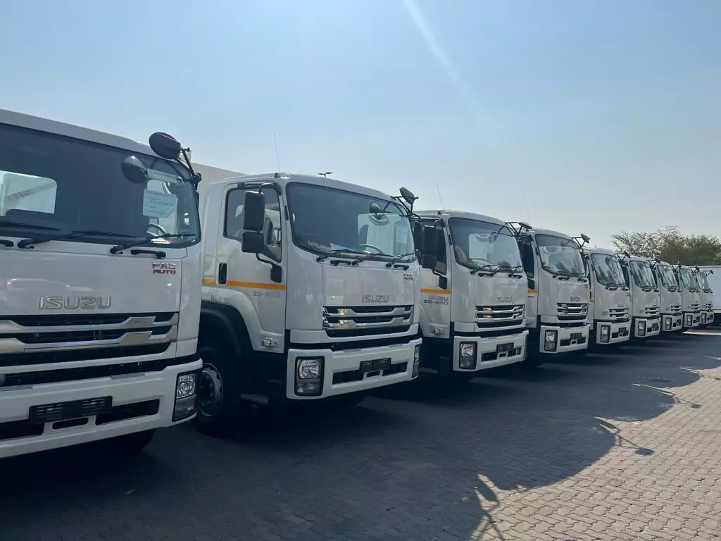
VISIT US
285 ERASMUS AVENUE
RASLOW, A.H,
CENTURION, 0157
SOUTH AFRICA
PHONE
+27 12 880 3155
CONTACT DETAILS

